Running head: INSTRUMENT FLIGHT PROCEDURE DEVELOPMENT

Safety Aspects of Instrument Flight Procedure Development

Bill Tuccio

Embry-Riddle Aeronautical University
Abstract

This paper discusses the history of instrument flight procedure development in the United States to present day. The current structure of the FAA Aviation System Standards office is discussed in detail along with key documents guiding the office. The history and structure of the Aviation Systems Standards office are tied together to demonstrate how the safety culture of the office creates a product with minimal defects.

Safety Aspects of Instrument Flight Procedure Development

Instrument flight procedures represent one of the mature processes of the aviation community. This paper will discuss the United States history of instrument flight procedures, charting and inspections along with the current policies and cultures comprising this discipline.
Historical Perspective
The history of instrument flight procedures can be broken down into the areas of navigation aids, charting and inspections. Each of these areas ultimately contributed capabilities to the other disciplines and provided lessons learned enabling the mature processes enjoyed today.
Navigation Aids
When air mail service started in the United States there was a concept of an “airway” yet no infrastructure to support such a concept. As Thompson said in Flight Check!,
The term “airway” was very loosely construed in 1918, as there was no actual route specified, nor were there any means of aerial navigation provided. There were no aeronautical charts, no terrain or obstruction information, and no radio capability for weather, communication, or navigation, much less anything resembling air traffic control. There was no civil aviation authority at either the state or federal level. There were no flight rules, nor, at that point, a real need for them (2002, p. 10).
The period from 1918-1929 resulted in the Bureau of Lighthouses defining an airway structure to support a mail route from New York to San Francisco based on 100,000 candle power spot lights, 1,000 watt marker beacons and 30 mile apart alternate landing fields (Thompson, 2002). The 1930’s introduced audio radio navigation with the four course range deployed under the newly created Airways Division.
VHF frequency usage began in the 1930’s as did demonstrations of the first vertical and horizontal radio guidance used for instrument letdown procedures, the first being at Newark, New Jersey. The late 1930’s saw the use of VHF frequencies to create the precursor to the VHF Omni-Directional Range (“VOR”) in the Visual-Aural Range (“VAR”) capable of producing two perpendicular courses. The VAR was delayed in deployment due to shortages of VHF equipment. This was fortunate as it paved the way for the far more useful VOR, which was deployed to over 271 locations from the late 1940’s into 1951 (Thompson, 2002).
The VOR period in the 1940’s into the 1950’s also saw the widespread deployment of the precision Instrument Landing System (“ILS”) with 150 systems commissioned by 1952 (Thompson, 2002).
The VOR period also saw the rollout of an initial Distance Measuring Equipment (“DME”) solution. In 1950, the CAA ordered 450 DME stations for collocated deployment with VOR stations. In the same period, the military was investigating an alternative DME solution, Tactical Air Navigation (“TACAN”). The civilian DME vs. TACAN resulted in a duplicate technology effort ultimately settled by a presidential committee in 1957, resulting in TACAN being the distance measuring solution of choice and collocations of VOR and TACANS now known as the VORTAC. Thompson notes operators had invested in the civilian DME solution and this caused some contention in the era (Thompson, 2002).
The DME played a pivotal role in the ability for flight inspections to be conducted without reference to the ground. As Thompson says, “The development of DME for accurate position fixing also signaled the coming of high-altitude all-weather flight inspection on a routine basis” (2002, p. 62).
The VOR, DME and ILS along with some low frequency beacons were the staple of air navigation until well into the late 1990’s, when satellite navigation began to play an increasing role.
Charting
The first U.S. aeronautical charts were published by the Coast and Geodetic Survey (CG&S) under the Department of Labor and Commerce in 1927 and were known as “strip charts”. These early strip charts covered the main air routes in existence and were found to be an inadequate charting solution (Thompson, 2002).
As soon as 1937, visual charts were developed and published covering the United States mainland. These charts grew into what today are known as VFR sectional charts (Thompson, 2002).
Instrument radio charts were first created in the 1930’s, an example of which is shown in FIGURE 1. The chart was released, but Thompson notes, “…the issuance of the charts noted they were for posting on airport bulletin boards but were not available for distribution to individual pilots.” (2002, p. 27). The chart notably omits any terrain altitude information.

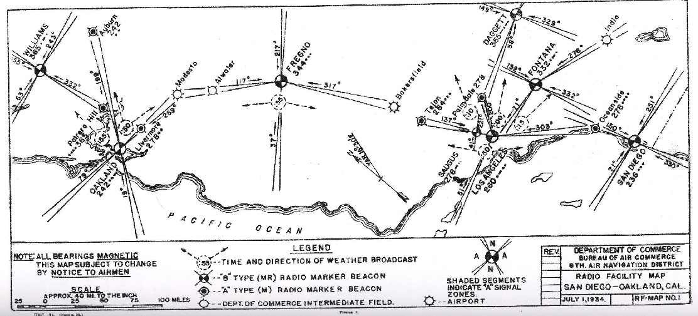
Figure 1. Early Aeronautical Chart. Note: From Thompson, S., 2002, Flight Check! The Story of FAA Flight Inspection, p.27. U.S. Government Printing Office.

By 1942, radio facility (“RF”) charts had matured to a published book format. RF charts eventually evolved into the IFR low and high altitude charts (Thompson, 2002).
Instrument approach procedures had their genesis not in the government, but in the private sector. One of the early pioneers was Elrey Jeppesen who created “rudimentary letdown procedures for airports” (Thompson, 2002, p. 131). United Airlines began using Jeppesen for their charting needs in the late 1930’s. An example of a 1945 letdown chart is shown in FIGURE 2 side-by-side with a 1998 instrument approach procedure. Of note, in 1945 no visibility minimums were published on the procedure.

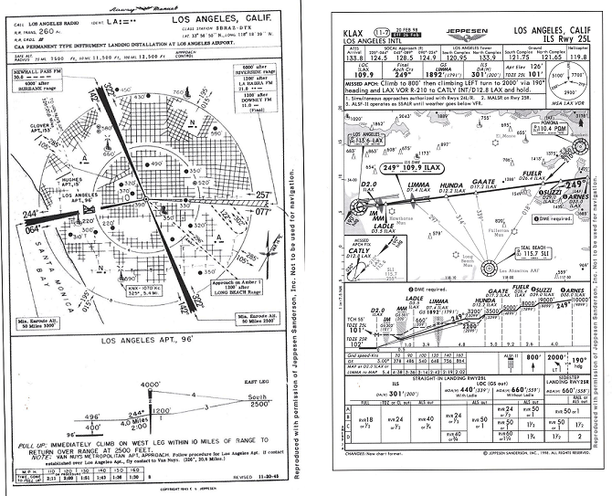

Figure 2. 1945 vs. 1998 LAX Instrument Approach Procedure. Note: From Thompson, S., 2002, Flight Check! The Story of FAA Flight Inspection, pp. 131, 133. U.S. Government Printing Office.

Instrument approach procedures were developed by pilots and airlines throughout the 1930’s with CAA inspectors reviewing and approving the procedures. The late 1930’s and 1940’s saw regional CAA offices developing instrument letdown procedures. In 1941 the CG&S first published letdown procedures and by 1949 had grown to a count of 483 charts. It was not until the 1950’s when standardization came to instrument procedures in the form of the Terminal Instrument Procedures manual (“TERPS”) (Thompson, 2002).
Inspection
Thompson defines flight inspection “as the various airborne evaluations of the navigation aids and flight procedures that compose a vital part of the national airspace system” (2002, p. 1). When the first airways were created in the early 1920’s, no process nor resources existed for airway inspection. By 1929, the Airways Division of the Bureau of Lighthouses had a shadow of an inspection program utilizing 11 aircraft and perhaps 20 pilots. Most of the work consisted of surveying proposed new routes with maintenance of ground lighthouses and beacons (Thompson).
With the advent of radio navigation in the early 1930’s, flight inspection was recognized as a critical need in order to navigate without ground reference. In 1932, the Department of Commerce employed six pilots for airway inspection along with developing a program to have airway users report discrepancies with airways. These early inspections were made by reference to ground checkpoints and there were no specifications for how the inspections were done. In lieu of reporting, pilots forwarded a monthly logbook to Washington, D.C. for review (Thompson, 2002).
The newly formed CAA was charged with “establishing flight inspection procedures and promoting standardized methods” in 1940 (Thompson, 2002). The development of standard flight inspection methods was a difficult task. In 1941 there were 30,913 miles of airways serviced by 16 airway pilots flying 10 Cessna T-50 twin engine aircraft (Thompson).
ILS and VOR technology came into existence just as World War II was beginning, slowing their deployment. Following World War II, the rapid deployment of these aids created new flight inspection challenges. Some of these challenges were met by surplus aircraft, including C-47’s (DC-3). In 1946, the varied flight inspection methods had a key step towards standardization with the CAA publication of the “Federal Airways Manual of Operations”. When this document was published, the typical flight inspection team consisted of one pilot for the DC-3 (no copilot), two journeyman flight inspectors and occasionally a clerk. The crew would evaluate all radio aids by flying patterns over ground checkpoints (Thompson, 2002). The nature of the staffing, resources and the VMC and ground visibility weather requirements of inspection caused one region to estimate in 1947 a workload of 4,500 flight inspection hours with only 1,500 flight hours available. The backlog of inspections was so great that in 1949 there were 250 installed VOR’s but only 26 had been commissioned (Thompson).
The early 1950’s saw the usage of one airborne technician and one ground based technician. The ground based technician would operate a surveyor tool, the theodolite, adapted for aviation purposes. The theodolite would provide accurate measurements relayed to the airplane. The theodolite was quickly adapted in the 1950’s to the Radio Telemetric Theodolite (RTT) which transmitted position information to the aircraft via a radio link. While the theodolite helped the efficiency of flight inspections, it still required VMC weather conditions and ground contact (Thompson, 2002).
The VMC limitations and the use of ground checkpoints for flight inspection was clearly a limit for the high altitude flying which was coming of age in the late 1950’s. The slow deployment of airway development– in terms of navigation facilities, radar and flight inspection– caused flight delays and was a cause in the infamous 1956 Grand Canyon mid-air collision of a TWA Constellation and United DC-7 over the Grand Canyon. This tragic accident caused an immediate cash infusion of $45 million (50% of the air navigation budget) and a six-year $450 million airway plan (400% of the 1956 budget) (Thompson, 2002).
The events of 1956 led to the replacement of the CAA by the FAA in 1959. During this transition period, the CAA published the “United States Standard Flight Inspection Manual”, a joint effort between the CAA and the various military services. Ten years later, flight inspection standards were bolstered by the TERPS publication in 1966 (Thompson, 2002).
The deployment of DME in the 1950’s set the stage for both high altitude flight inspection and flight inspection without reference to the ground. The late 1950’s saw the deployment of Semi-Automatic Flight Inspection (SAFI). This technology allowed the measurement of VOR positions by using the intersection of multiple DME arcs to obtain accurate position and was a pivotal event in the history of flight inspection (Thompson, 2002).
The period from the 1960’s to the 1970’s saw the introduction of jet aircraft into flight inspection along with inertial navigation (INS) and by 1978 the creation of the Automated Flight Inspection (AFIS) to replace the SAFI system (Thompson, 2002). Of course, during this period, the advent of computer technology was pivotal in how information could be stored and processed.
Instrument Flight Procedures and Flight Inspection Today
Organizational Structure
This history of charting, navigation and flight inspection was filled with an undercurrent of seemingly continuous reorganizations of the federal bureaucracy. Today, air navigation in the United States falls under the control of the Aviation Systems Standards division of the FAA, created in 1982 with the mission of “Providing services to ensure the standard development, evaluation, and certification of airspace systems, procedures, and equipment for customers worldwide” (AVN Web Site, n.d.).
The National Flight Procedures Office (NFPO) reports to the AVN and is responsible for “the global development and maintenance of both terminal and enroute instrument flight procedures.” The NFPO reports in 2007 40% of all instrument flight procedures are satellite based and steadily increasing (NFPO website, n.d.).
The Flight Inspections Operations Group operates 31 aircraft with 188 employees logging 20,000 flight hours annually under FAR Part 135 flight rules. The group has six regional offices in the United States and “ensures the integrity of instrument approaches and airway procedures” (Flight Inspections Operations Group Website, n.d.). The group is supported by the Aircraft Maintenance and Engineering group.
The National Aeronautical Charting Office (NACO) is responsible for the “compilation, reproduction, and distribution of aeronautical navigation products and digital databases for the U.S., its territories and possessions”. NACO information comes from its own data collection, the Federal Communication Commission (FCC) and the National Flight Data Center (NFDC) (NACO website, n.d.).
The Safety and Quality Assurance Office of the AVN verifies the quality of the AVN operation. The office states, “Throughout this web site, you will discover evidence of our commitment to continued safety improvement. We believe safety is not embodied in an order, memorandum, or individual policy. Rather, we believe it is a culture that must be fostered and encouraged at all levels and within each person of the organization. Each individual's energy and attention must be focused upon risk reduction and the elimination of behavior that can lead to incidents and accidents” (Safety and Quality Assurance Office WebSite, n.d.).
Guiding Documents
The key documents mentioned in the history section of this paper continue to be improved to meet the changing needs. These documents include:
- Order 8200.1C, “U.S. Standard Flight Inspection Manual” contains the policy and procedures for the conduct of flight inspections.
- Order 8200.8, “Flight Inspection Program Standards” contains the standards and certifications requirements for conducting flight inspections. Whereas 8200.1C specifies procedures, 8200.8 is a more technical, foundational document. An example of a foundational principal in this document is shown in FIGURE 3.
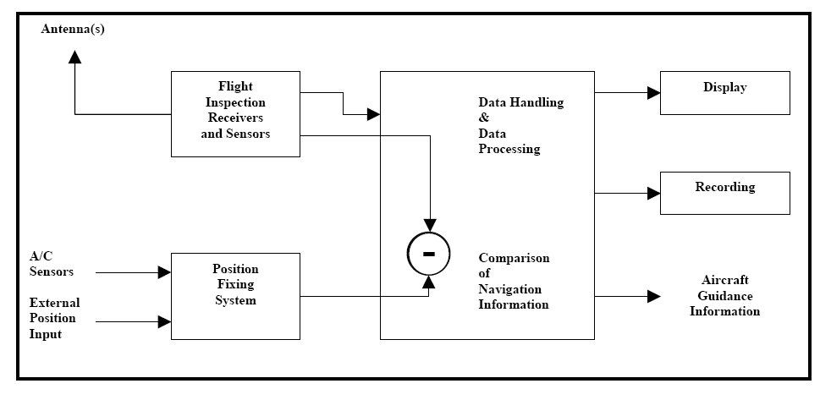
Figure 3. Fundamental Flight Inspection Principal. Note: From FAA., 2007, Flight Inspection Program Standards, VN 8200.8, p. 8.

- Order 8260.3B, “United States Standards for Terminal Instrument Procedures” (“TERPS”), contains the guidelines and standards for the design of instrument procedures (originally published in 1966).
- Order 8240.52, “Aeronautical Data Management”, contains the procedures for flight inspection data management.
Conclusions
Today’s Aviation Systems Standard’s Office represents a mature safety organization. The various offices and organizations enable the operations of each of the other independent offices. The safety culture of the organization creates a constantly improving structure along the lines of mature process models, such as the Capability Maturity Model Level V.
The fielding of a new instrument approach procedure has a rigidly defined process based on nearly 100 years of history including an application process, site survey followed by procedure development, initial inspection and recurring inspection. The AVN offices have a risk prioritized production plan in order to manage the finite resources of its various offices (AVN Website, n.d.).
Accident statistics reflect the rigid process of instrument flight procedure development. From 1950 thru 2006, there are few (if any accidents) attributed to flawed instrument approach procedures or defective radio navigation aids where the flight crew could have broken the accident chain (PlaneCrashInfo.com, n.d.).
References
Aviation Systems Standards (AVN) Web Site. (n.d.). Retrieved January 24, 2008 from http://www.avn.faa.gov/index.asp?xml=index.
Federal Aviation Administration. (2007). Flight Inspection Program Standards, VN8200.8. Washington, D.C.: Author.
Flight Inspection Operations Group Web Site (n.d.). Retrieved January 24, 2008 from http://www.avn.faa.gov/index.asp?xml=fioo/index.
National Aeronautical Charting Office (NACO) Web Site (n.d.). Retrieved January 24, 2008 from http://www.avn.faa.gov/index.asp?xml=naco/about.
National Flight Data Center (NFDC) Web Site (n.d.). Retrieved January 24, 2008 from http://nfdc.faa.gov/index.jsp.
National Flight Procedures Office (NFPO) Web Site (n.d.). Retrieved January 24, 2008 from http://www.avn.faa.gov/index.asp?xml=nfpo/index.
PlaneCrashInfo.com (n.d.). Retrieved January 26, 2008 from http://www.planecrashinfo.com/cause.htm.
Safety and Quality Assurance Office WebSite. (n.d.). Retrieved January 24, 2008 from http://www.avn.faa.gov/index.asp?xml=safety/index.
Thompson, S. (2002). Flight Check! The Story of FAA Flight Inspection. Washington, DC: US Government Printing Office.

